Cooke Access Portal (CAP)
Scholar Manual for Young Scholars and Parents of Young Scholars

Introduction 3
Accessing CAP - Scholars 3
Dashboard 4
About Me 4
My Academic Institutions 5
My Grades 8
My School Lists 12
My Test Scores 16
My Communications 17
To Do List 19
Accessing CAP - Parents 20
Parent Dashboard 20
Add a Parent/Guardian 20

Introduction

Welcome to the Cooke Access Portal (CAP), a system created by the Jack Kent Cooke Foundation to help Scholars fulfill their scholarship requirements. Scholars will use CAP throughout their time as a Cooke Scholar to input grades, test scores, upload transcripts, build high school and college lists, communicate with the Foundation, and perform other required tasks. Parents/Guardians may also access CAP to view their Scholar’s CAP account and to grant/remove access to an additional parent/guardian. Parents will have a read only view of their Scholar’s account. Please see the CAP Parent Access section later in this manual for further information.

Accessing CAP - Scholars

To sign in, go to https://jkcf.org/cap and log into your account. If you have forgotten your password, click the Forgot Password? link to set a new one.

The sign in screen will look like this:

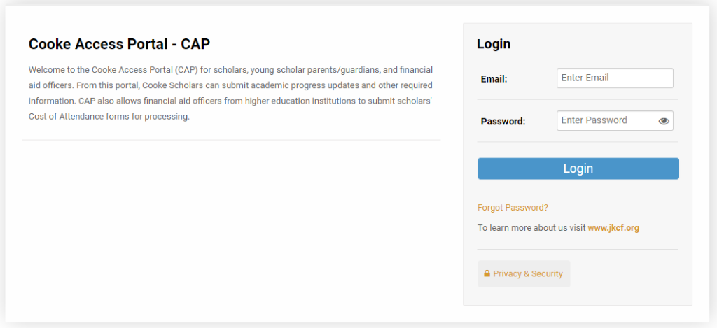

Dashboard

When you first login, you will start on your CAP dashboard. In the upper right corner of the screen, you will also see a link to My Dashboard. Clicking on this link will take you back to your main dashboard. From the dashboard, you can update your personal information, upload your grades, upload your test scores, submit your school lists, communicate with the Cooke Foundation, and access your personal To Do Lists.

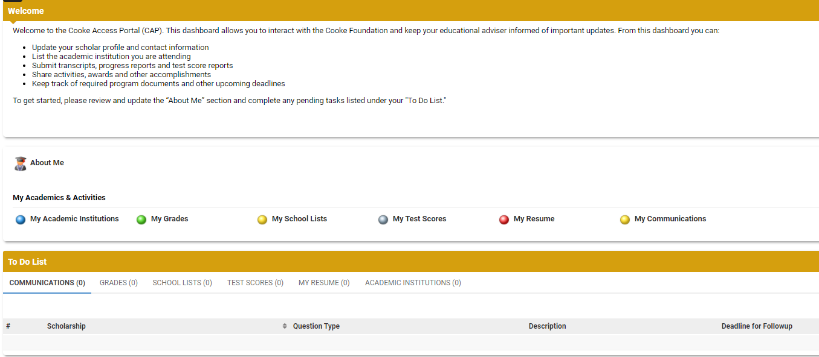

About Me

To get started, click on the About Me icon on your dashboard. About Me is where you review and edit your contact and personal information. You must keep your information up to date; it is the primary way in which the Foundation will communicate with you. Please note that you will be prompted periodically to update your information. The reminder will appear in red text under the welcome message on your dashboard.

Remember to click the Save button on the bottom of the page when you are finished updating each of the tabs. When you have updated all the tabs, click on the Profile Up-To Date button.

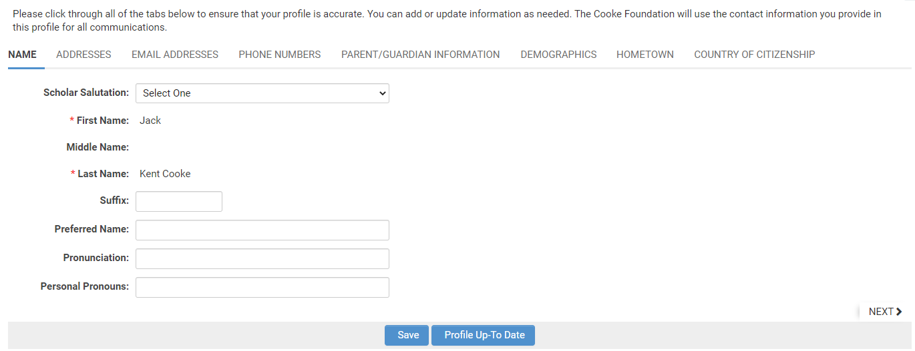

Name
Use this tab to add your preferred name (if you prefer a name different from your legal name), provide pronunciation of your name, and share your personal pronouns. If your legal first or last name changes, please contact us at cap@jkcf.org with changes to your name.

Remember to click the Save button on the bottom of the page when you are finished updating data in each of the sections.

Addresses
Use this tab to provide the Foundation with your address(es). To edit, add, or delete your address(es), click the Add/Edit Addresses link. From there, you may edit any of your addresses or add a new address by clicking the New Address button. Make sure to properly designate your addresses (School, Permanent, Temporary) and indicate the address you would like the Foundation to use as your primary address. We will periodically mail correspondence to your primary address.

Email Addresses
Your primary email address is also your username for the system. If you use other email addresses, please enter them in the Email Addresses tab, but keep in mind that the address in the Primary Email field is the one you will use to log in to CAP. Changing your primary email address will change the username you use to sign in. If we have trouble reaching you at your primary email address, we may attempt to reach you at the additional email addresses you provide.

Phone Numbers
Enter your primary phone and any other phone numbers where you may be reached.

Parent/Guardian Information
Your parents’/guardians’ information is pre-populated from your scholarship application. There are spaces for multiple Parents/Guardians. If only one is listed, you may add additional Parents/Guardians or leave it blank. If your parents’/guardians’ contact information changes at any point during your time as a Scholar, please be sure to update their information promptly.

Demographics and Hometown
Some of the fields in your profile were populated from information in your scholarship application. You may update your demographic and hometown information at any time. If you find that you are unable to make a change and/or see a mistake that you are unable to update, please contact the Cooke Foundation at cap@jkcf.org.

Country of Citizenship
If your country of citizenship changes, please update it on this tab. If you have dual citizenship, please note both countries of citizenship.

My Academic Institutions

In the My Academic Institutions section, we ask you to provide information about the middle school and high school you are/will be attending.

Please update the About Me section before adding a new academic institution.

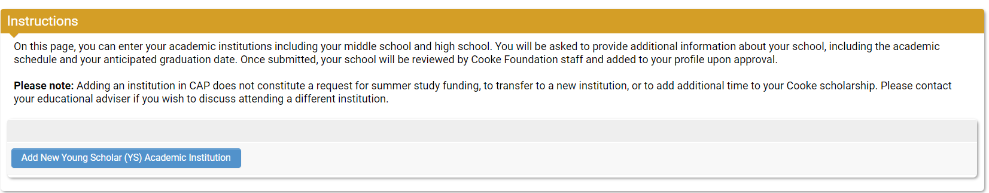

Adding a New Academic Institution

- Click the Add New Young Scholar (YS) Academic Institution button.
- Select one of the following as the type of institution and click Save:
  - Middle School – if you are enrolled at a middle school.
  - High School – if you are enrolled at a high school.
  - Homeschool – if you are homeschooled.
  - Community College – if you are dual enrolled at a community college (you should also enter your middle school/high school as appropriate).
  - College/University – if you are dual enrolled at a college or university (you should also enter your middle school/high school as appropriate).

The pages for the various school types are similar, in that they all require you to enter the institution's schedule and your enrollment status. In addition, if you attend a Community College or College/University, you will also be prompted to enter your Anticipated Degree.
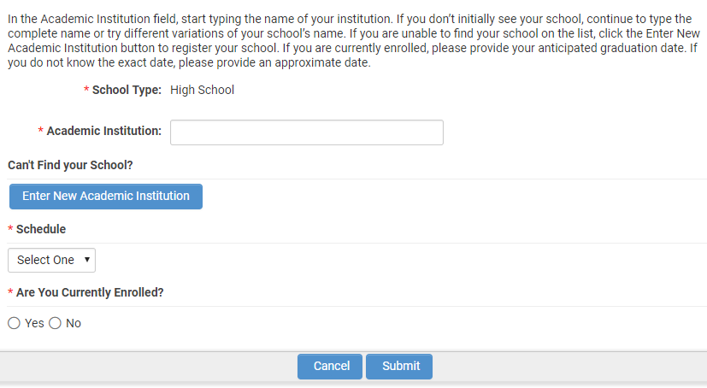

- In the Academic Institution field, start typing the name of your school. As you type, a list of schools will auto-populate. If your school is listed, select it. If you don’t initially see your school, continue to type the complete name or try different variations of your school’s name.
If you are unable to find your school in the auto-populated list, refer to the next section in this manual titled Registering a New Academic Institution to register your school.

- From the Schedule dropdown, select your school’s academic calendar. The choices are Semester, Quarter, or Trimester. If you do not know your school’s academic schedule, please refer to your school’s website or ask your school counselor.

- Indicate if you are currently enrolled at this institution.

  - If you are currently enrolled or will be soon, select Yes and enter your Anticipated Graduation Date. If you are unsure of your graduation date, please provide your best estimate.
  - If you are no longer enrolled at the institution, select No and answer the “Did you Graduate?” question. If you select Yes, enter your graduation date and the term in which you graduated.

- If your school is a community college or college/university, click on the Enter Degree(s) button to enter your intended degree and major information. Click the plus “+” button to add a degree.

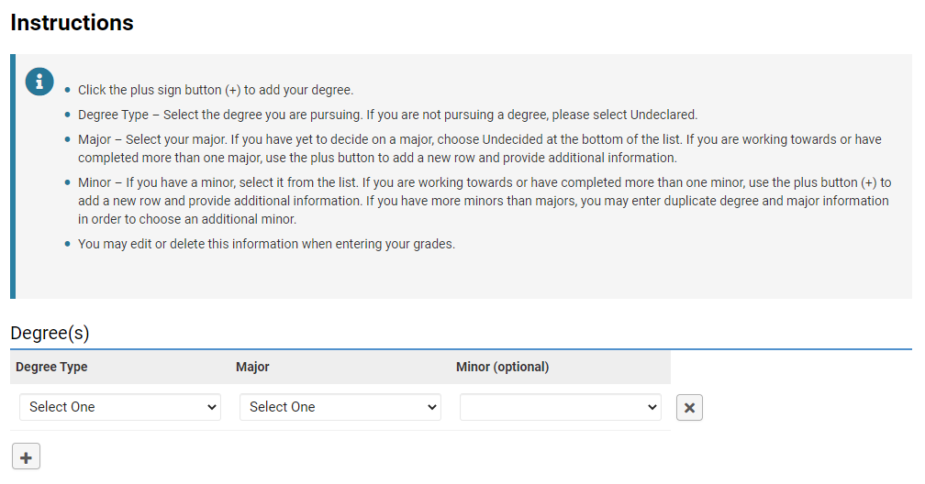

  - Degree Type – Select the degree you are pursuing or plan to pursue. If you are not pursuing a degree, please select Undeclared.
  - Major – Select your major. If you have yet to decide on a major, choose Undecided at the bottom of the list. If you are working towards or have completed more than one major, use the plus “+” button to add a new row and provide additional information.
  - Minor – If you have a minor, select it from the list. If you are working towards or have completed more than one minor, use the plus “+” button to add a new row and provide additional information. If you have more minors than majors, you may enter duplicate degree and major information to choose an additional minor.

You may edit or delete degree information when entering your grades. See the My Grades section for further details.

- Once you are finished entering your information, click the Save and Close buttons to save your information and close the window.

- When you have entered all required information, click the Submit button on the bottom of the Add New Academic Institution page. Once submitted, Cooke Foundation Staff will verify your school information within a few business days.

Registering a New Academic Institution

If you were unable to find your institution in the dropdown list, you must register your school with the Foundation by providing the school’s information. Follow the steps below to register your school. Once you do, Cooke Foundation Staff will verify the school and add it to the system. After the school is added to the system, you will be prompted to complete the academic institution portion of your profile.

- On the Add New Academic Institution form, click the Enter New Academic Institution button.

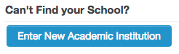

- A window will pop up asking you to provide your school’s name, address, and website as well as your name, phone number, and email address.
- Click the Submit button at the bottom. Cooke Foundation Staff will verify your school within 1-2 business days and then notify you via email when you may complete the academic institution section of your profile.

My Grades

The Foundation requires Scholars to submit grades/progress report cards at the end of every term. Promptly submitting your grades is required to maintain good standing in your scholarship program. You are only required to enter your current term information in CAP. Please do not enter past terms.

At the end of every term, you will receive an email notification that it is time to submit your grades in CAP. A request to enter grades will show up on your To Do List on your dashboard. Please note you will not be able to submit grades until the request appears on your To Do List.

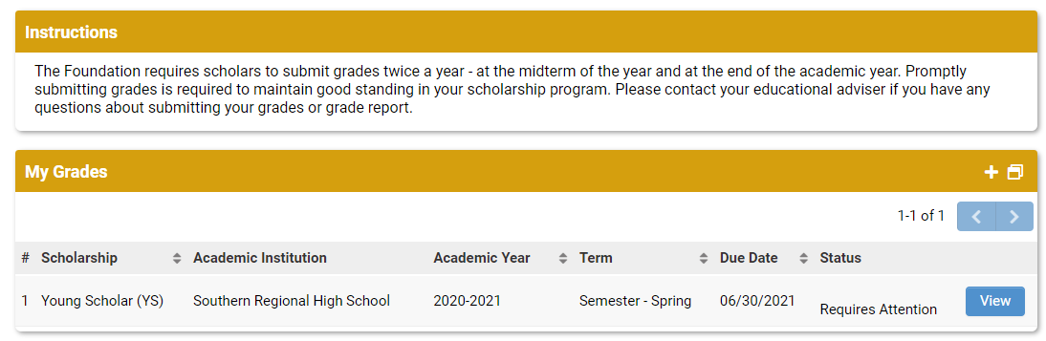

Adding New Grades

Before you enter your grades, you must have a copy of your most recent grade report/transcript. You cannot edit your grade entry once you click Submit, therefore do not start this process until all your grades have been posted by your school. Your grade report/transcript must contain data for all the required fields.

- To begin entering your grades, click on the Grades tab on your To Do List.
- Click the View button next to the school for which you are submitting grades.

- Enter your year in school and academic year.
- Enter the school term for which you will be entering grades.
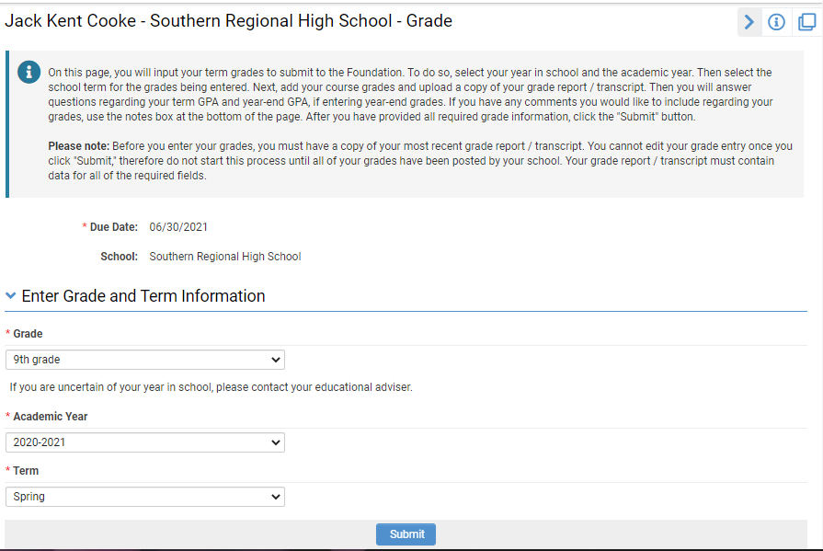

- Click the Enter Course(s) button. A new window will open where you may enter individual course information. To add a course, click on the plus “+” button to add grade information for each of your courses for the term.

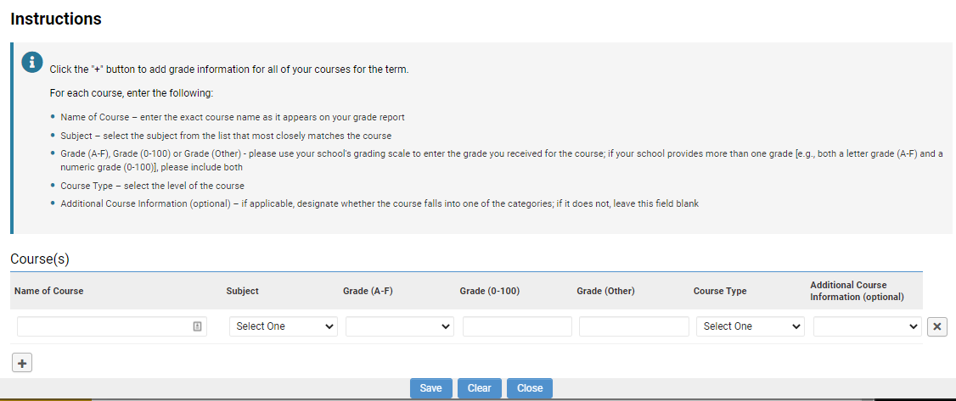

For each course, enter the following:
  - Name of Course – enter the exact course name as it appears on your report card
  - Subject – select the subject from the list that most closely matches the course
  - Grade (A-F), Grade (0-100) or Grade (Other) - please use your school's grading scale to enter the grade you received for the course; if your school provides more than one grade [e.g., both a letter grade (A-F) and a numeric grade (0-100)], please include both
  - Course Type – select the level of the course
  - Additional Course Information (optional) – if applicable, designate whether the course falls into one of the categories; if it does not, leave this field blank

Click the plus “+” button to add grade information for each of your courses for the term. The following is a screenshot of this page populated with sample grade information:

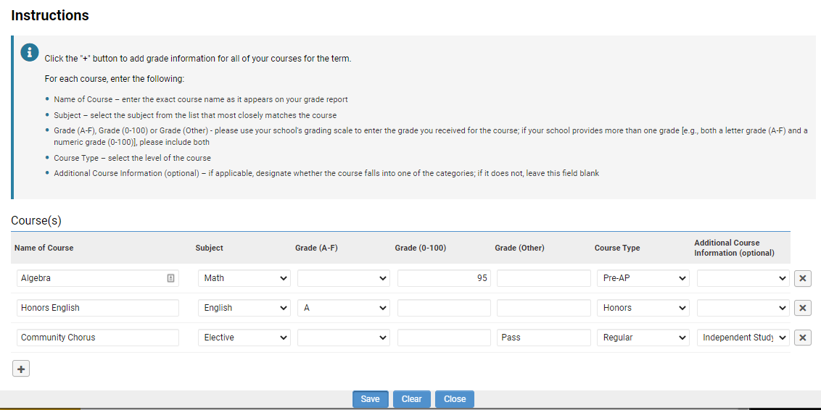

- After you have finished entering all your course and grade information, click the Save and Close buttons on the bottom of the page.
- Click on the Upload button under Upload School Grade Report/Transcript. This will open a file manager upload window. You may either drag your report card/transcript file into the window from your computer or click the folder icon to find and select the file to upload. If you have only a paper report card/transcript, scan and save it as a file or take a clear photo with your phone and upload the image. Please be sure your grade report/transcript has your full name listed and your school information.
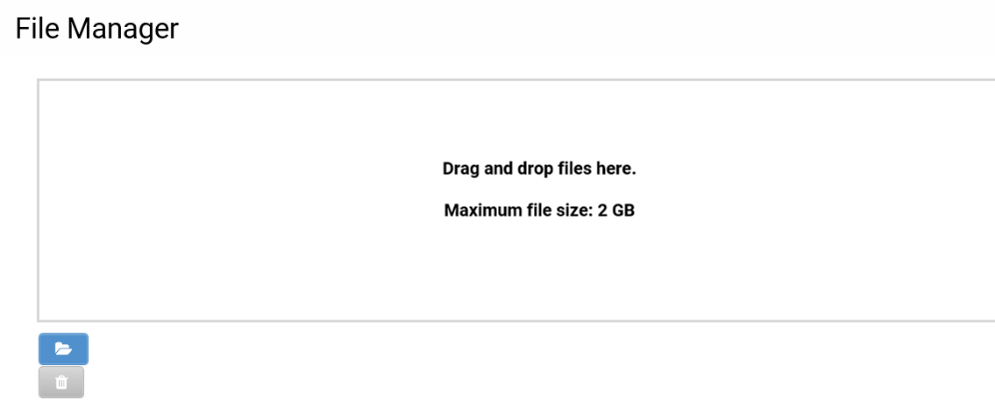
- Answer the questions regarding your term and cumulative GPAs as well as year-end GPA if entering year-end grades. If your grade report/transcript lists a term GPA, select Yes and enter your term GPA. If your school does not provide term GPAs, select No and provide an explanation as to why there is no term GPA. Do the same for the following question regarding cumulative GPA (and year-end GPA, if applicable).
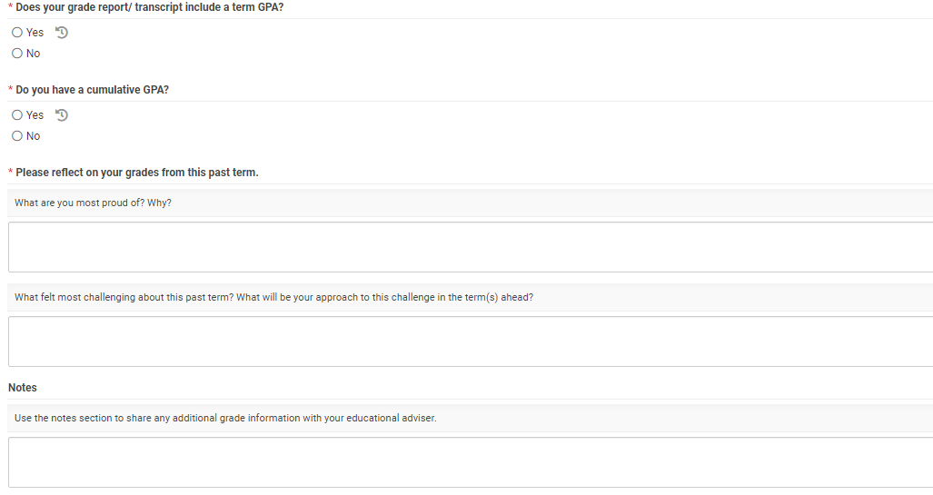

- Please reflect on your grades from the past term by answering the two reflection questions. If you have any additional comments you would like to include regarding your grades, use the notes section at the bottom of the page.
- After you have provided all required grade information, click the Submit button.

My School Lists

The Foundation requires you to submit a high school list and a college list during your time as a Young Scholar. You will be notified when it is time to enter your school list in CAP and a task will show up in your To Do List on your dashboard. Please note you will not be able to start your school list until the request appears on your To Do List.

High School List

The Foundation requires you to submit a high school list during your eighth-grade year to track the high school(s) you are interested in researching as well as those to which you are planning to apply.

During the fall of eighth grade, you will be notified that your high school list is available in CAP. A task to enter you high school list will show up in your To Do List on your dashboard.
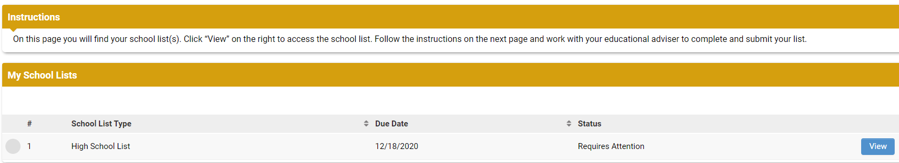

- To begin entering your high school list, click on the view button to the right.

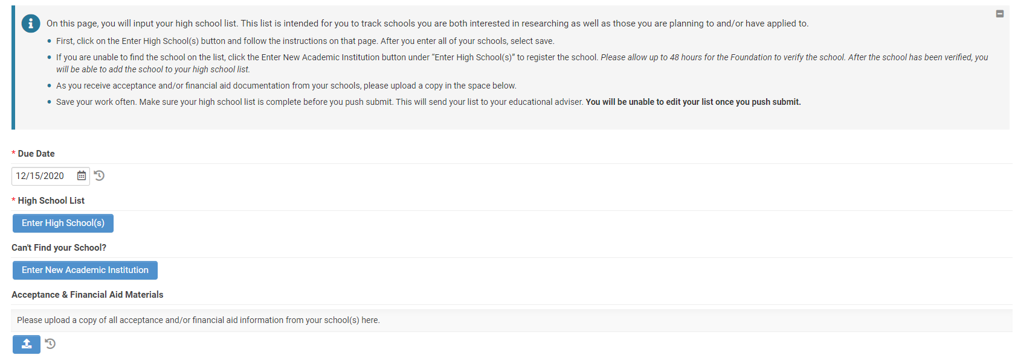
- Click the Enter High School(s) button to begin entering your high school(s) of interest.

- For each high school, enter the following:
  - School Name – enter the exact school name (no abbreviations or acronyms)
  - School Type – select the type from the list that most closely identifies your school – the options are: charter, homeschool, magnet, private (board), private (day), public, other
  - Application Status – select the application status that relates to the current status of your application for each school. If no application is required (i.e., for your local public school), select “No application required”.
  - Application Deadline – enter the application due date for all schools that require an application. You may leave this field blank if you entered “No application required” for the application status.

- If you are unable to find the high school you are interested in, please click the Enter New Academic Institution button to register the new school. Please allow up to two business days for the Foundation to verify the school. After the school has been verified, a Foundation Staff member will contact you to let you know that you may move forward with adding the high school to your list.

- Click the plus “+” button to add additional high schools to your list. Once completed, click the Save and Close buttons. You can save your work as you go.

- Upload a copy of acceptance and/or financial aid information to the Acceptance & Financial Aid Materials upload field. These materials may be submitted at any point throughout the high school admissions process.

- Once your high school list is final and you are ready to submit it to your educational adviser for review, click the Submit button.

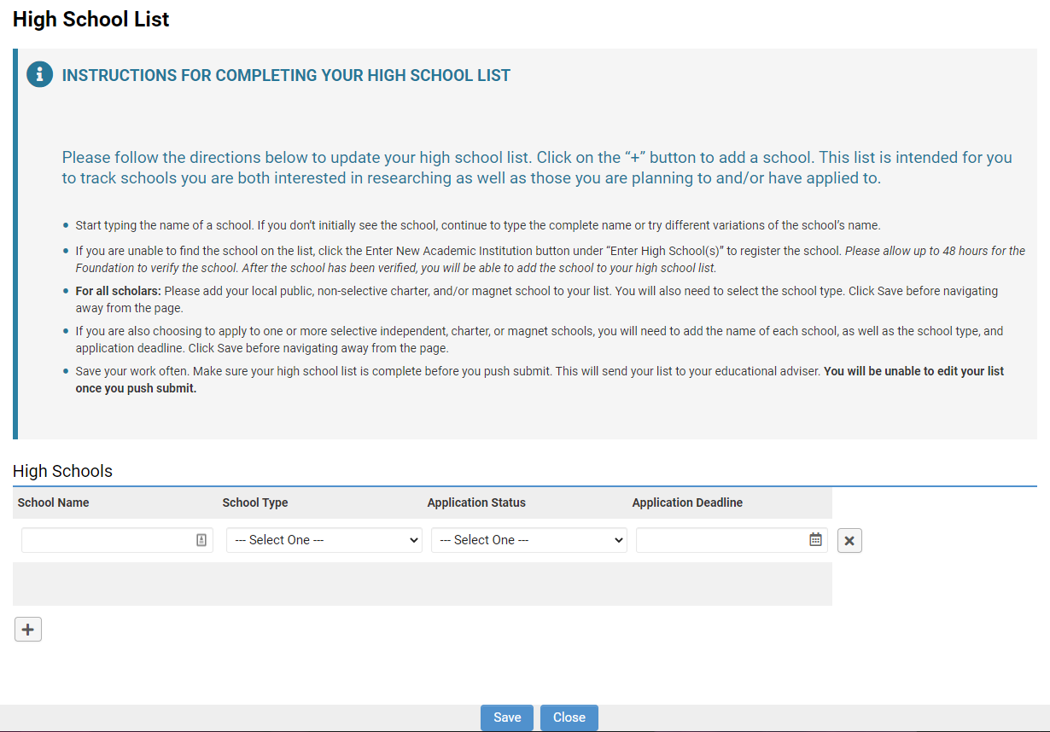

College List

The Foundation requires Scholars to begin working on a college list during junior year, to track the colleges you are interested in researching as well as those to which you are planning to apply.

During the spring of your junior year, you will be notified that your college list is available in CAP. A task to enter your college school list will show up in your To Do List on your dashboard.

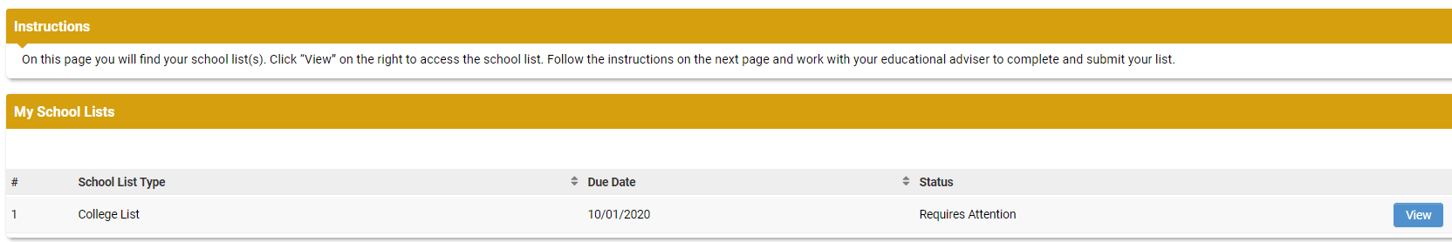

- To begin entering your college list, click the view button to the right.

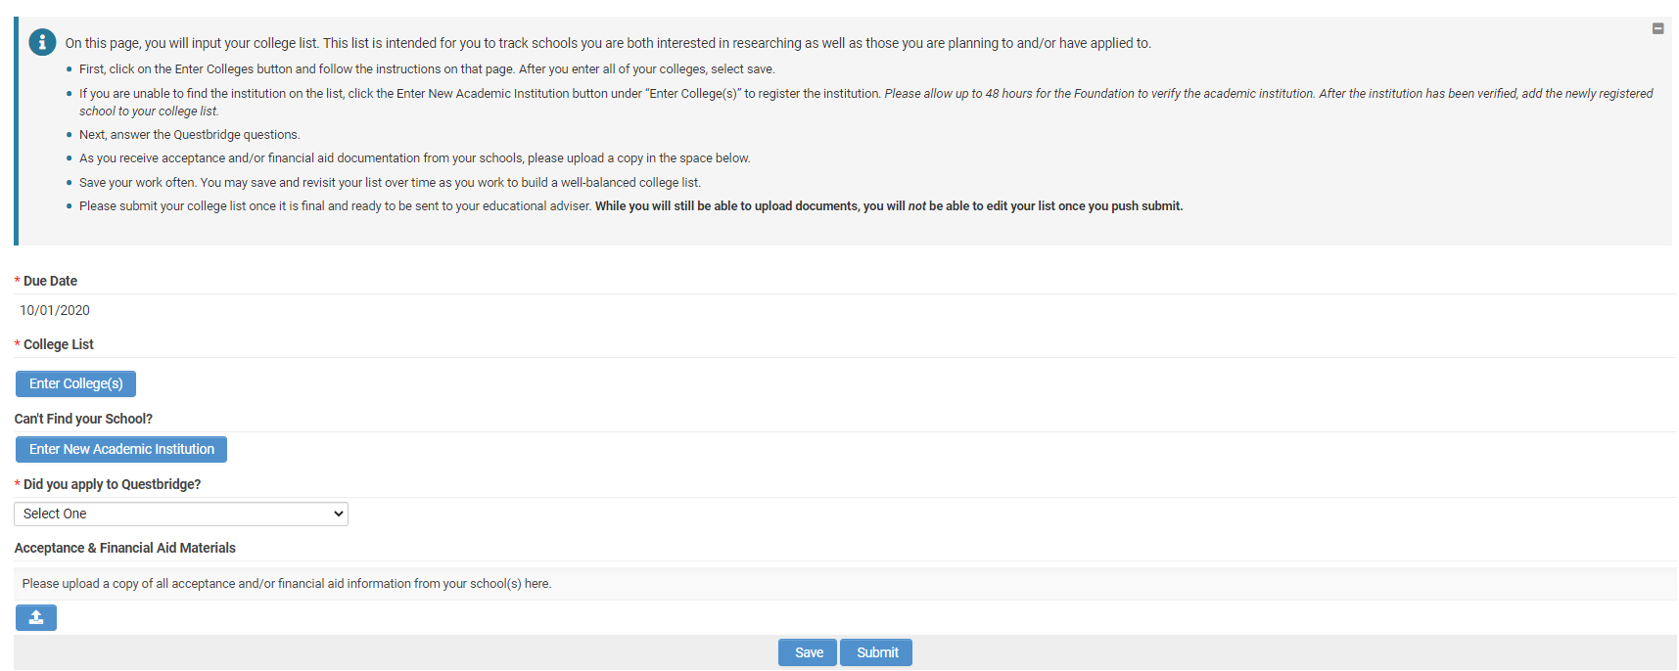
- Click the Enter College(s) button to begin entering your colleges of interest.

- For each college, enter the following:
  - School Name – enter the exact school name (no abbreviations or acronyms)
  - Application Status – select the application status that relates to the current status of your application for each institution
  - Admission Type – note whether you are applying early action, early decision, regular, etc.
  - Application Deadline – enter the application due date for each institution

- If you are unable to find the institution are interested in adding to your list, please click the Enter New Academic Institution button to register the new institution. Please allow up to two business days for the Foundation to verify the academic institution. After the institution has been verified, a Foundation Staff member will contact you to let you know that you may move forward with adding the school to your list.

- Click the plus “+” button to add additional institutions to your list. Once completed, click the Save and Close buttons. You can save your work as you go.

- Provide an answer to the Questbridge question. Please note, if you apply to Questbridge, you will receive an additional request through CAP for further information later.

- Upload a copy of acceptance and/or financial aid information to the Acceptance & Financial Aid Materials upload field. These materials may be uploaded at any point during the college application process.

- Once your list is finalized and you are ready to submit it to your educational adviser for review, click the Submit button.

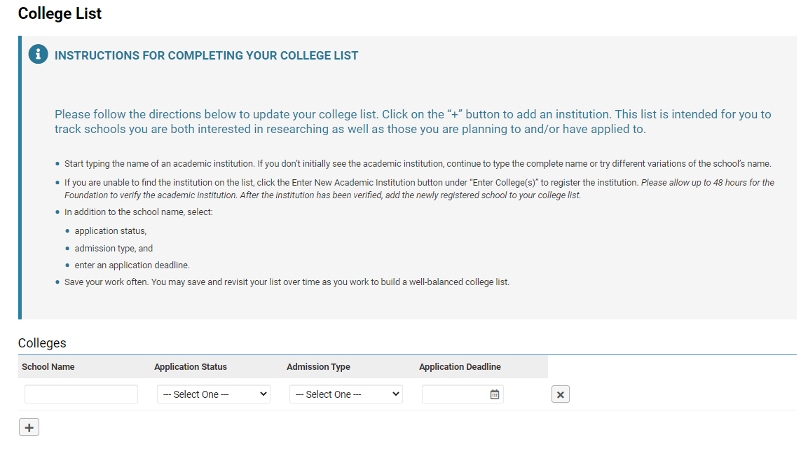

My Test Scores
Test scores are requested twice a year by the Foundation. Additional test scores can be uploaded in CAP throughout the year as well. Before you enter your test scores, you must have a copy of the score report(s). For each test you take, the fields are customized for that particular test. Below is a screenshot of the fields required for an AP test:

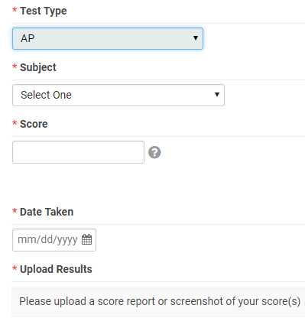

After entering your test scores, click the Save button.

Click on the Upload button under Upload Results. This will open a file manager upload window. You may either drag your score report file into the window from your computer or click the folder icon to find and select the file to upload. If you have only a paper score report, scan and save it as a file or take a clear photo with your phone and upload the image.

My Communications

You may use the My Communications section to communicate with the Foundation. To access the communications tool, click on the My Communications link on your dashboard. This is the screen that will appear:

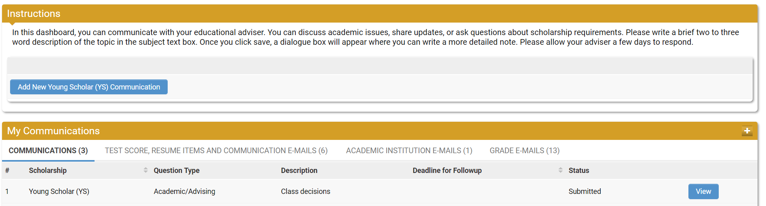

Creating a New Communication

- To create a new communication, click the Add New Young Scholar (YS) Communication button.
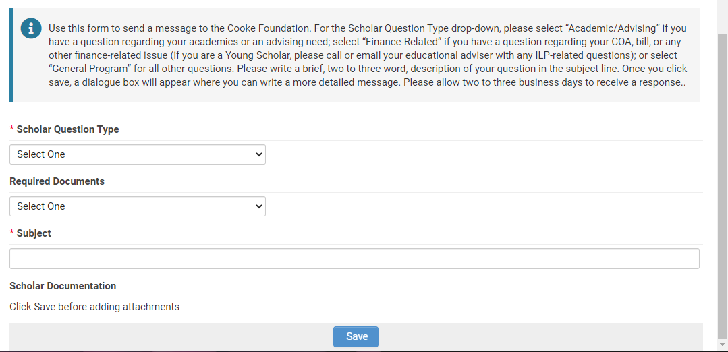

Select a Scholar Question Type.
  - Academic/Advising – if you have an academic or advising question.
  - General Program – if you have a general program question.

- In the Subject line, enter a brief description of your topic. This is like the subject line in an email.
- Click the Save button.

- If you have documents pertinent to your communication, click the Upload button under Scholar Documentation to upload a document.
- On the left-hand side of the screen, you will see a menu with a Notes link.
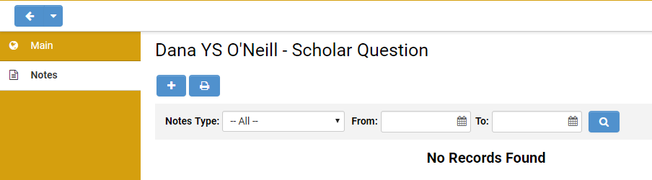

- Click on Notes. Then click on the plus “+” button to open a text box where you can type your question/message.
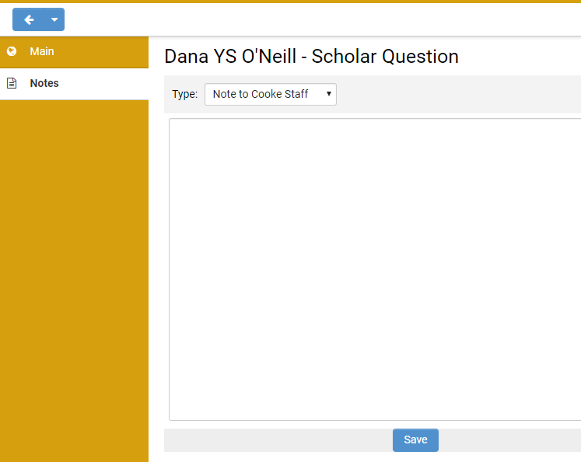

- Click Save when you are done entering your message.
- Click the Main link on the left-hand navigation, then click the Submit button on the bottom of the page to submit your communication to the Foundation.
Please note: If you click the Enable Dock button in the upper right corner of the screen, it will open the Notes screen to the right and keep the Main screen open as well. After you dock the screen, start with #7 above to enter your question/message.

To Do List

Your To Do List is located at the bottom of your dashboard. It will list all tasks requiring your attention.

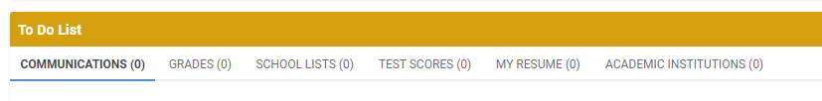

Communications

When you receive a response to a communication you submitted or receive a new communication from the Foundation, a new item will appear on the Communications tab of your To Do List. Click the View button to review (and respond to) the communication.

Grades
At the end of every term, we will ask you to submit your grades. When grades are due, you will see a new item on the Grades tab of your To Do List. Click the View button to access the grades form.
School Lists
The Foundation requires you to submit a high school list and a college list during your time as a Young Scholar. You will be notified when it is time to enter your school list in CAP and a task will show up in your To Do List. Click the View button to access the school lists.

Test Scores
Periodically we will ask you to submit your test scores. When test scores are due, you will see a new item on the Test Scores tab of your To Do List. Click the View button to access the test score form.

Academic Institutions

From time to time we may ask you to update information regarding your academic institution. If so, a new item will appear on the Academic Institution tab of your To Do List. Click the View button to access the Academic Institutions page and update your information.

Accessing CAP - Parents

Young Scholar parents/guardians sign into CAP here: https://jkcf.org/cap. Your username and password were created for you and emailed from youngscholarsprogram@jkcf.org. If you have forgotten your password, click the Forgot Password? link and follow the instructions.

The sign in screen will look like this:

Parent Dashboard

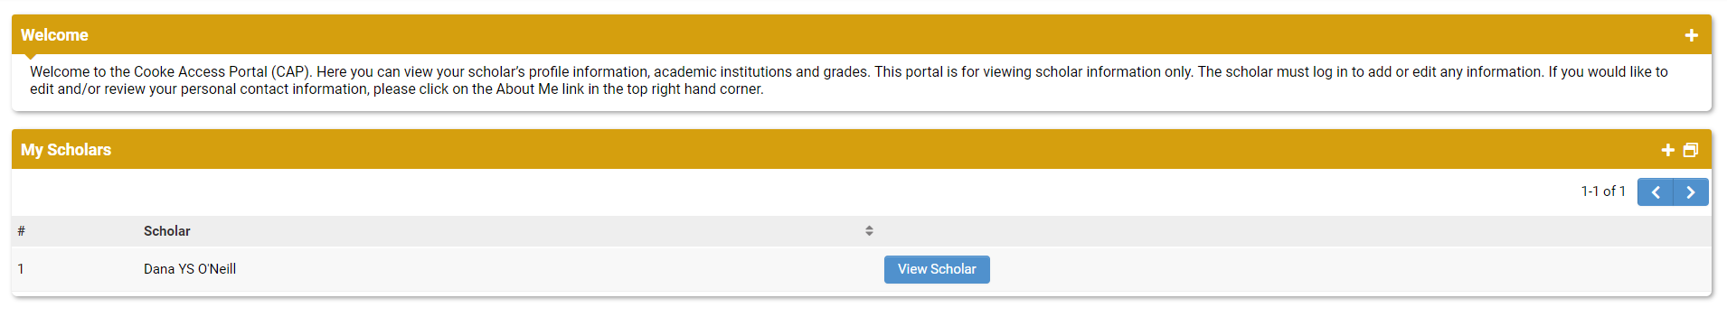
The first screen after you login is your CAP Dashboard. There is a welcome message at the top and a My Scholars list. In the upper right corner of the screen is a link to your account where you may change your password or logout.

Through CAP, you may view a “read-only” version of your Scholar’s profile information. This includes your Scholar’s academic institution(s), grades, school lists, test scores, and communications. The “read-only” view means that you are not able to make any changes to your Scholar’s account; instead, your Scholar must log in to their account to add or edit any information.

Add a Parent/Guardian
The parent/guardian that completed the online application has been given initial access to CAP. This parent/guardian may add any other parents/guardians to the Scholar’s account.

- Click on the View Scholar button next to your Scholar’s name on your dashboard. This will open your Scholar’s profile.

- Click on the Parent/Guardian Access button at the bottom of the screen.

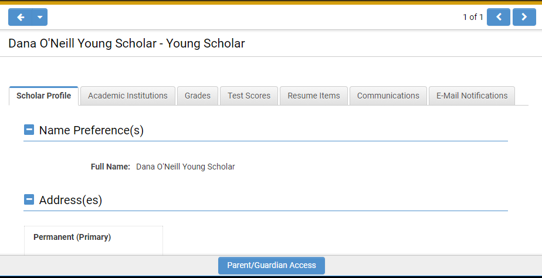

- Click the plus “+” button on the bottom left of the screen and fill in the first name, last name, and email address of the Scholar’s other parents/guardians.

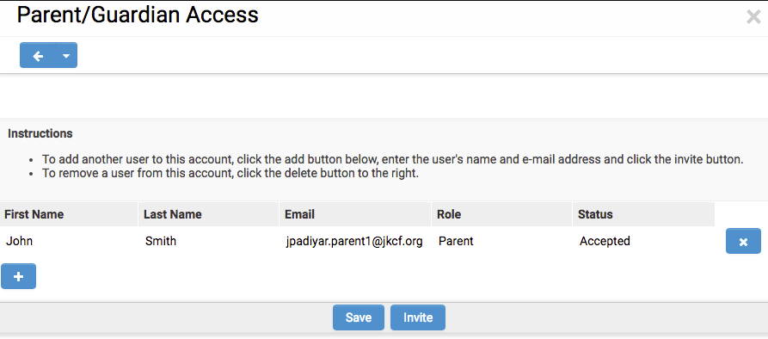

- Once you are done adding parents/guardians, click the Invite button at the bottom of the screen.

Please note: The primary parent/guardian also can remove access from any other parents/guardians. Please contact the Cooke Foundation if there is any confusion about this or if there are any changes to parents/guardians.

